


Software Safety Requirements and Architecture

Lane Assistance
Document Version: 2.0
Version 1.0, Released on 2018-04-29

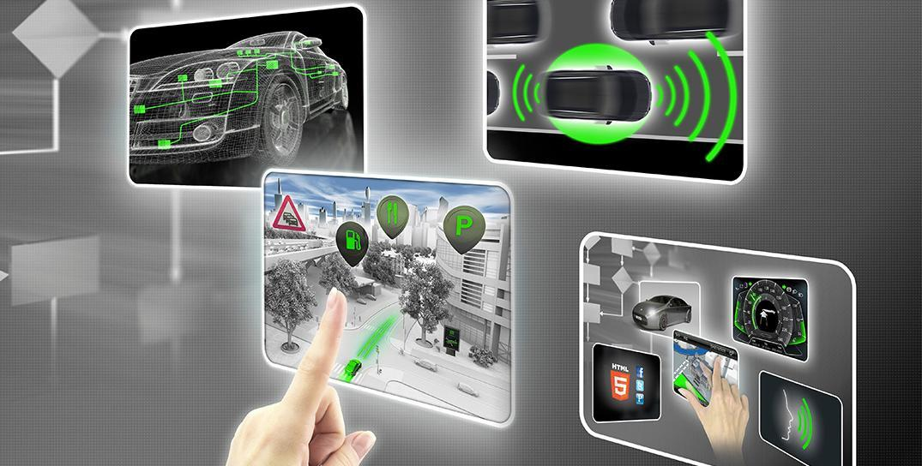

Document history

Date | Version | Editor | Description
04/29/2018 | 1.0 | Ninad Ghike | Initial Creation
05/15/2018 | 2.0 | Ninad Ghike | Update safe state

Table of Contents

Document history
Table of Contents
Purpose
Inputs to the Software Requirements and Architecture Document
Technical safety requirements
Refined Architecture Diagram from the Technical Safety Concept
Software Requirements
Refined Architecture Diagram

Purpose
The purpose of the Software Safety Requirements and Architecture Lane Assistance is to define software safety requirements

Inputs to the Software Requirements and Architecture Document

Technical safety requirements
Technical Safety Requirements related to Functional Safety Requirement 01-01 are:
ID | Technical Safety Requirement | ASIL | Fault Tolerant Time Interval | Architecture Allocation | Safe State
Technical  Safety  Requirement  01 | The LDW safety component shall ensure that the amplitude of the 'LDW_Torque_Request' sent to the 'Final electronic power steering Torque' component is below 'Max_Torque_Amplitude. | C | 50 msec | LDW Safety Functionality | LDW will set the oscillating torque amplitude to 0
Technical  Safety  Requirement  02 | The 'LDW Safety' software block shall send a signal to the car display ECU to turn on a warning light as soon as the LDW function deactivates the LDW feature. | C | 50 msec | LDW Safety Functionality | LDW will set the oscillating torque amplitude to 0
Technical  Safety  Requirement  03 | The LDW function shall deactivate the LDW feature and the 'LDW_Torque_Request' shall be set to zero as soon as a failure is detected. | C | 50 msec | LDW Safety Functionality | LDW will set the oscillating torque amplitude to 0
Technical  Safety  Requirement  04 | The system shall check for the timeouts of ‘LDW_Torque_Request’ Signal | C | 50 msec | Data Transmission integrity check | LDW will set the oscillating torque amplitude to 0
Technical  Safety  Requirement  05 | The system shall perform memory check of the EPS ECU at bootup to look for memory related faults. | A | Ignition Cycle | Safety Startup | LDW will set the oscillating torque amplitude to 0

Refined Architecture Diagram from the Technical Safety Concept

Software Requirements

Lane Departure Warning (LDW) Amplitude Malfunction Software Requirements:

ID | Technical Safety Requirement | ASIL | Fault Tolerant Time Interval | Allocation to Architecture | Safe State
Technical  Safety  Requirement  01 | The LDW safety component shall ensure that the amplitude of the 'LDW_Torque_Request' sent to the 'Final electronic power steering Torque' component is below 'Max_Torque_Amplitude. | C | 50 msec | LDW Safety Functionality | LDW will set the oscillating torque amplitude to 0

ID | Software Safety Requirement | ASIL | Allocation Software Elements | Safe State
Software  Safety  Requirement  01-01 | The input signal “Primary_LDW_Torq_Req” shall be read and pre-processed to determine the torque request coming from the ‘Basic/Main LAFunctionality’ SW Component.  Signal “processed_LDW_Torq_Req” shall be generated at the end of the processing. | C | LDW_SAFETY_INPUT_PROCESSING | N/A
Software Safety Requirement 01-02 | In case the “processed_LDW_Torq_Req” signal has a value greater than “Max_Torque_Ampltide_LDW” (maximum allowed safe torque), the torque signal “limited_LDW_Torq_Req” shall be set to 0, else “limited_LDW_Torq_Req” shall take the value of “processed_LDW_Torq_Req”. | C | TORQUE_LIMITER | “limited_LDW_Torq_Req” = 0(Nm=Newton-meter)
Software Safety | The “limited_LDW_Torq_Req”shall be transformed into a signal | C | LDW_SAFETY_OUTPUT_GENERATOR | LDW_Torq_Req= 0 (Nm)

ID | Technical Safety Requirement | ASIL | Fault Tolerant Time Interval | Allocation to Architecture | Safe State
Technical  Safety  Requirement  02 | The 'LDW Safety' software block shall send a signal to the car display ECU to turn on a warning light as soon as the LDW function deactivates the LDW feature. | C | 50 msec | LDW Safety Functionality | LDW will set the oscillating torque amplitude to 0

ID | Software Safety Requirement | ASIL | Allocation Software Elements | Safe State
Software Safety Requirement02-01 | Each of the software elements shall output a signal to indicate any error which is detected by the element. Error signal = error_status_input (LDW_SAFETY_INPUT_PROCESSING), error_status_torque_limiter (TORQUE_LIMITER), error_status_output_gen (LDW_SAFETY_OUTPUT_GENERATOR) | C | All | N/A
Software Safety Requirement02-02 | A software element shall evaluate the error status of all the other software elements and in case any 1 of them indicates an error, it shall deactivate the LDW feature (“activation_status”=0) | C | LDW_SAFETY_ACTIVATION | Activation_status = 0 (LDW function deactivated)
Software Safety Requirement02-03 | In case of no errors from the software elements, the status of the LDW feature shall be set to activated (“activation_status”=1) | C | LDW_SAFETY_ACTIVATION | N/A
Software Safety Requirement02-04 | In case an error is detected by any of the software elements, it shall set the value of its corresponding torque to 0 so | C | All | LDW_Torq_Req = 0
Software Safety Requirement02-01 | Each of the software elements shall output a signal to indicate any error which is detected by the element. Error signal = error_status_input (LDW_SAFETY_INPUT_PROCESSING), error_status_torque_limiter (TORQUE_LIMITER), error_status_output_gen (LDW_SAFETY_OUTPUT_GENERATOR) | C | All | N/A

ID | Technical Safety Requirement | ASIL | Fault Tolerant Time Interval | Allocation to Architecture | Safe State
Technical  Safety  Requirement  03 | The LDW function shall deactivate the LDW feature and the 'LDW_Torque_Request' shall be set to zero as soon as a failure is detected. | C | 50 msec | LDW Safety Functionality | LDW will set the oscillating torque amplitude to 0

ID | Software Safety Requirement | ASIL | Allocation Software Elements | Safe State
Software Safety Requirement 03-01 | When the LDW function is deactivated (activation_status set to 0), the activation_status shall be sent to the Car Display ECU | C | LDW_SAFETY_ACTIVATION, CarDisplay ECU | N/A

ID | Technical Safety Requirement | ASIL | Fault Tolerant Time Interval | Allocation to Architecture | Safe State
Technical  Safety  Requirement  04 | The system shall check for the timeouts of ‘LDW_Torque_Request’ Signal | C | 50 msec | Data Transmission integrity check | LDW will set the oscillating torque amplitude to 0

ID | Software Safety Requirement | ASIL | Allocation Software Elements | Safe State
Software Safety Requirement 04-01 | Any data to be transmitted outside of the LDW Safety component (“LDW Safety”) including “LDW_Torque_Req” and “activation_status” (see SofSafReq 02-02) shall be protected by an E2E protection mechanism | C | E2E Calculation | LDW_Torq_Req= 0
Software Safety Requirement 04-02 | The E2E protection protocol shall contain and attach the control data: alive counter (SQC) and CRC to the data to be transmitted. | C | E2E Calculation | LDW_Torq_Req= 0

ID | Technical Safety Requirement | ASIL | Fault Tolerant Time Interval | Allocation to Architecture | Safe State
Technical  Safety  Requirement  05 | The system shall perform memory check of the EPS ECU at bootup to look for memory related faults. | A | Ignition Cycle | Safety Startup | LDW will set the oscillating torque amplitude to 0

ID | Software Safety Requirement | ASIL | Allocation Software Elements | Safe State
Software Safety Requirement 05-01 | A CRC verification check over the software code in the Flash memory shall be done every time the ignition is switched from off to on to check for any corruption of content | A | MEMORYTEST | Activation_status = 0
Software Safety Requirement 05-02 | Standard RAM tests to check the data bus, address bus and device integrity shall be done every time the ignition is switched from off to on (e.g. walking 1s test, RAM pattern test. Refer RAM and processor vendor recommendations) | A | MEMORYTEST | Activation_status = 0
Software Safety Requirement 05-03 | The test result of the RAM or Flash memory shall be indicated to the LDW_Safety component via the “test_status” signal | A | MEMORYTEST | Activation_status = 0
Software Safety Requirement 05-04 | In case any fault is indicated via the “test_status” signal the INPUT_LDW_PROCESSING shall set an error on error_status_input (= 1) so that the LDW functionality is deactivated and the LDW Torque is set to 0 | A | LDW_SAFETY_INPUT_PROCESSING | Activation_status = 0

Refined Architecture Diagram

